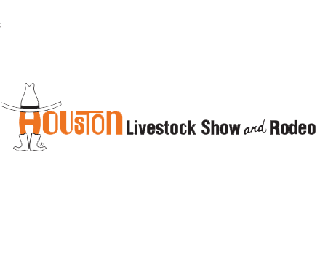

Houston Livestock Show & Rodeo
December 2014

2014 Houston Livestock Show and Rodeo Wine Competition Results

CLASS CHAMPION / DOUBLE GOLD
2012 Maison L’Envoy Bourgogne Rouge

CLASS CHAMPION / GOLD
2011 Oveja Negra Single Vineyard Carmenére
2010 d'Arenberg d'Arry's Original
CLASS CHAMPION / PACIFIC RIM / GOLD
2014 Innocent Bystander Pink Moscato
GOLD
2010 Chilcas Las Almas
CLASS CHAMPION / PACIFIC RIM / SILVER
2013 d'Arenberg The Hermit Crab Viognier Marsanne
2012 Penley Estate Condor

SILVER
2012 Chilcas Reserva Cabernet Sauvignon
2011 Chilensis Lazuli
2010 d’Arenberg Laughing Magpie Shiraz/Viognier
2012 Penley Estate Phoenix
2010 Penley Estate Hyland
2010 Penley Estate Reserve Cabernet Sauvignon
2012 Stickybeak Cabernet Sauvignon
2011 Stickybeak Toscana
2013 Shoofly Shiraz
2013 Dobbes Grand Assemblage Pinot Noir
2013 Dobbes Grenache Blanc
2011 Poggiotondo Chianti Superiore
BRONZE
2013 Oveja Negra Reserva Carmenére
2011 Single Vineyard Carignan
2013 Wine by Joe Pinot Noir
2010 Chateau de Sours Bordeaux Rouge

