
Plexus SGM Overview
By John Duval
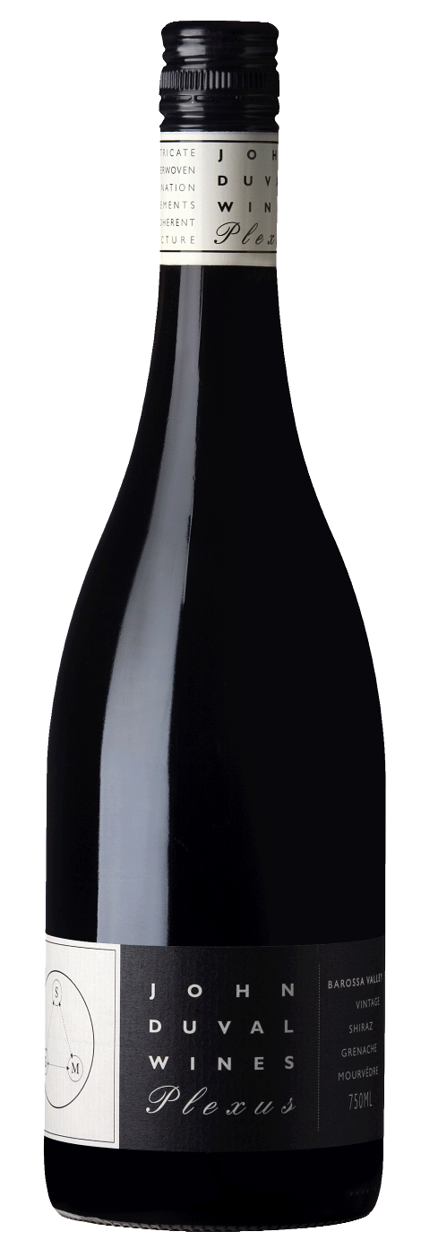
May 2014

- First vintage 2003
- Eleven vintages made
- Current vintage 2012
Many people were expecting when I left Penfolds, my first release would be small volumes of high end Shiraz. But in a region that boasts the oldest Shiraz, Grenache and Mourvedre vines in the world, I decided to focus on this famous Barossa Valley blend. GSM in category but Plexus is always a SGM blend; ideally 50%, 30% and 20% respectively.
- Shiraz provides the blackberry core structural backbone.
- Old vine, low yielding Grenache (some over 100 years old) provides aromatics and texture.
- Old vine, low yielding Mourvedre (the oldest 115 years old) add savory, spice and earthy notes.
Stylistically I am not aiming for the fruits bombs high alcohol interpretation, but rather Plexus is a respectful, elegant expression of very old Barossa Valley vineyards. 100% barrel maturation in 300 liter hogsheads with only 10% new French oak. While drinking well as a young wine, Plexus does mature well with good cellaring conditions. The first vintage 2003, is now a lovely mature wine showing a complex array of savory and mature berry notes and a generous core of sweet fruit and soft tannins.
2003 – 94 pts (WA), 93 pts (W&S)
2004 – 95 pts (AWC), 93 pts (WA), 91 pts (WS)
2005 – 93 pts (IWC), 92 pts (WA)
2006 – 95 pts (WA), 95 pts (AWC), 92 pts (IWC)
2007 – 93 pts (AWC), 92 pts (IWC)
2008 – 95 pts (AWC), 93+ pts (WA), 93 pts (IWC), 90 pts (WS)
2009 – 96 pts (AWC), 92 pts (IWC), 92 pts (WS)
2010 – 92+ pts (WA), 92 pts (IWC)
2011 – 91 pts (WS), 91 pts (IWC)

