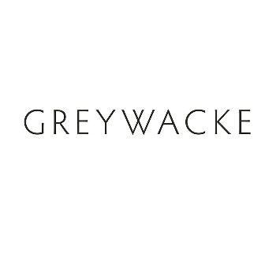
2023 GREYWACKE
SAUVIGNON BLANC

Review Summary

92 pts “Fragrant aromas of candied citrus, guava and orange blossoms followed by nettles, sage and box trees. Medium-bodied, mouthwatering acidity. Vibrant and aromatic. Drink now.”

JamesSuckling.com
November 2023

